Dog Needs a Forever home
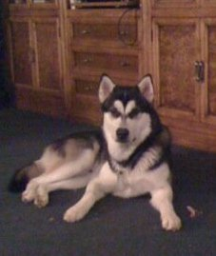
Alaskan Malamute

He is a 2 year old spayed Alaskan Malamute named Nugget (weighs about 75 pounds). He has tags and is microchipped, has all shots and very, very friendly. He is house trained and loves other dogs (especially small ones). We are traveling too much to keep him.

The perfect home would have a large yard, kids (at least 5 years old), another dog, people who would love this hairy beast sleeping in house at night, someone home most the time and has experience with Northern breeds.

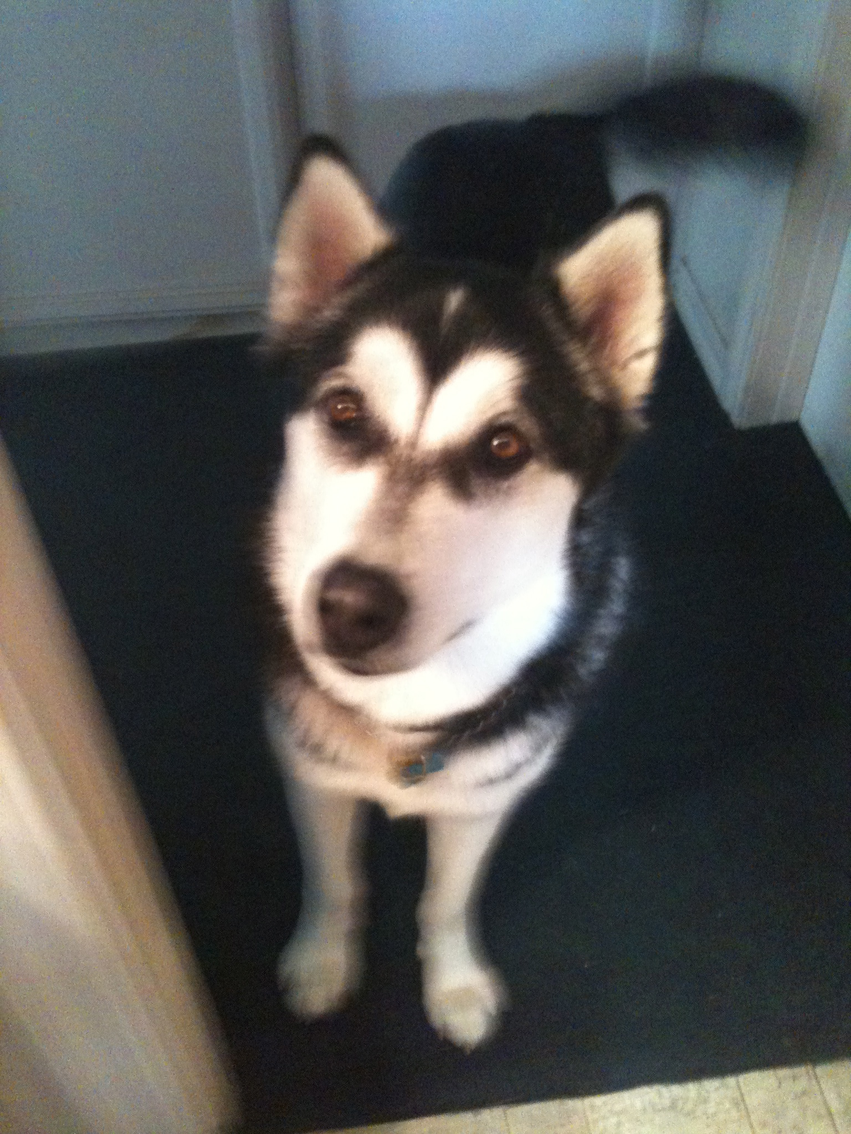
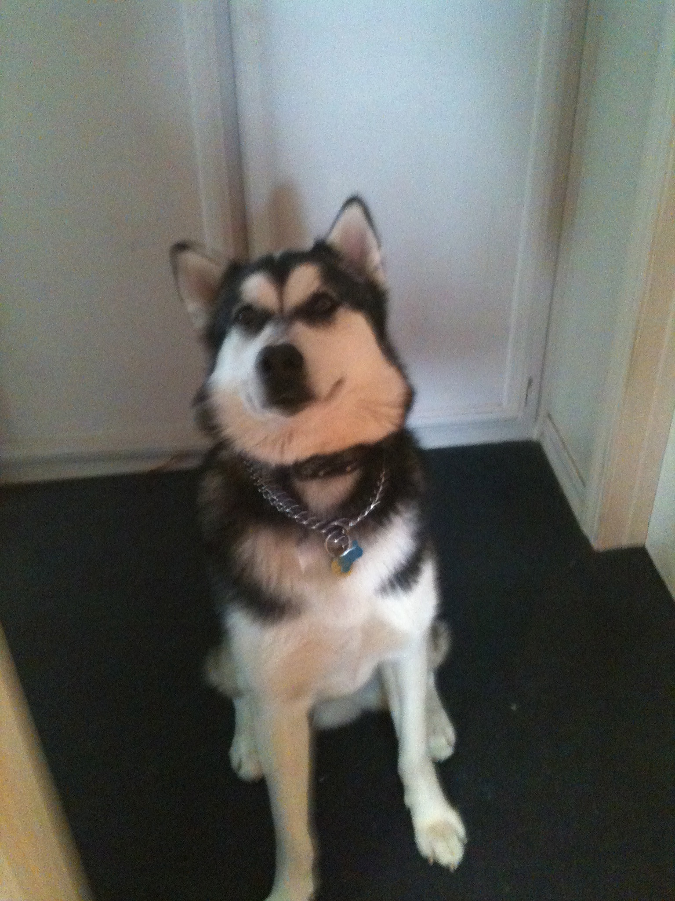

Please call (805) 305-0579 to meet him.

